|  |
| --- |
| **Human Computer Interaction** |
| A cooperative evaluation of last.fm |
|  |
| 2nd part of our heuristic evaluation of Last.fm |
|  |
| Jennifer Allen - 0848832 |
| Gavin Fitzgerald – 0857173  David O'Neill - 0813001 |
| **4/16/2010** |
|  |

Table of Contents

About the project 4

Introduction 4

Cooperative Evaluation Prototype 5

Task List 5

Search 5

Play tracks 5

Registering 5

Music library control 6

Social networking (send, receive messages & add friends) 6

Find Help & Support 6

How We Recruited 7

Participant 1 7

Participant 2 7

Participant 3 8

Participant 4 8

Participant 5 8

Declaration of Consent 9

Test Environment 9

The Process 10

Test Cases Breakdown & Analysis 10

Search 10

Playing Tracks 11

Registering 13

Music library control 14

Social networking (send / receive messages, add friends) 17

Find Help / support and identify email support 19

Outcomes 21

Overall - informal overall evaluation 21

Visibility of system status 21

Match between system and the real world 22

User control and freedom 22

Consistency and standards 22

Error prevention 23

Recognition rather than recall 23

Aesthetic and minimalist design 24

Design Recommendations 25

Visual Colour, Shape and Size of Buttons 25

Number of Actions Required 25

Expected Functionality 26

Help & Documentation 26

Conclusions and Lessons Learned 27

Citations 28

Screenshots 29

1. (Searching) Multitude of search inputs 29

2. (Playback control) Misleading Advertisement 29

3. (Registering) feedback, error prevention 30

4. (Library Control) "Save" Button Colour Scheme 30

5. (Library Control) "Hidden" delete button 31

6.  (Help & Documentation) Support email hidden 31

7. (Library Control.) Add content models 32

8. (Library Control) Success models 32

9. (Social Networking) Sending message 33

# About the project

## Introduction

This is the 2nd part of our heuristic evaluation of Last.fm, where we completed a co-operative evaluation involving observed user-involved tests and an examination of the results from these tests.

Cooperative evaluation is a general method of usability testing. Rather than using an in-house, trained group of testers, approximately people, considered to be likely users of the system, are brought in to test the product, or service and observed/interviewed with their opinion/emotions on the system recorded.

Last.fm is a community oriented driven music website, providing a variety of music related features such as artists recommendations, upcoming events, video and radio streaming. For a larger breakdown into what Last.fm is and why we chose it, please refer to Assignment 1, "A heuristic evaluation of last.fm".

# 

# Cooperative Evaluation Prototype

## Task List

### Search

Since the majority of the interaction with the website involves finding new bands and information related to them and acts as the entry point to the website and its intended use.  We thought it a prudent choice to have searching as our first step.  We ask each participant to identify the search options available and then proceed to find information related to their tastes.  Since this was an easy option to for our participants to identify it seemed a great place to ease them into the tasks to come.

### Play tracks

The next step after exploring the search functions, we asked the participant to play some music.  As with most sites, sticky content is a great way to keep users interested in their site. For the majority of people who arrive onto the last-fm music site their initial exploration of the site implies access to music media, more than just plaint old text content and images.    
  
We asked the participants to identify ways of playing music media.  During this process a user should become aware of some of the limitations, such as 30 second time limitations on tracks.  To listen to more they would have to register.

### Registering

The registration process is mandatory to most sites nowadays, and thought to be the make it or break it part of the site.  The user would identify how to register, fill out the last.fm form, and finally confirm their account via the email confirmation message.

### 

### Music library control

This task was an amalgamation of the adding and removing tracks as well as steps from task 2 'playing' tracks.  The user had to identify a path or paths to complete the task of adding a single track and then removing that track from their music library.  The task was designed to identify problems with affordances implied by some buttons and consistency issues we thought as Human Computer Interaction students would be problematic to some users.

### Social networking (send, receive messages & add friends)

As we identified from our exploration in the heuristic evaluation any major feature of the website is the social media aspect. For this talk we asked the user to add a friend (which was an account we had already set up). The participant would have to find this user on the site and add them as a friend. Once added as a friend the user would then send a message to this user, a message would then be sent back to the participant and he / she would identify where to view and identify if they had indeed received a new message in their respective inbox.

### Find Help & Support

For our final task, we asked the user to find the FAQ, help forums and other help documentation and for their impressions of these.  A sub process of this was for them to find a direct support email address if they could and go through the steps of carrying out this.

## 

## How We Recruited

We began by deciding together the likely users of the site. They'd likely have regular access to a PC, and be at least competent in use of computers as a media playing device and in use of an Internet browser.

Probable users would have an interest in any kind of music, be of any race or gender (Last.fm is an international site, available in 12 different languages) and be in the age group of 10 - 50 when considering technical knowledge required and age groups that use other popular social networking sites.

After we had decided these requirements, we each found suitable candidates and kindly asked for them to partake in our evaluation.

Participant 1  
Described himself as an average user and is currently studying Multimedia and Games Development. Is in the 18 – 25 age group. He was our first participant and the analysis was the most frustrating for him, as there were multiple issues arising resulting him in loosing interest in the evaluation.  Never the less we completed the tasks.

### Participant 2

Described her self as an average user and is currently studying Music, Media and Performance technology.  It was an easy experience for her and her ability perform the tasks was unrivalled in the group.

### Participant 3

Described him self as an average user.  Is in the 18 - 25 age groups, currently studying Arts   
Was very talkative, and expressed a wealth of thoughts and impressions.

### Participant 4

Described him self as an average user.  He was the least able and confident of our users.  But we found his ability to take his time and read everything made it an easy experience for him. He is currently Studying Health Sciences in the age group 18 - 25. 

### Participant 5

He described him self as an expert in the field of computing.  He is currently studying for a BSC in computing, in the age group 18 - 25.   He had a valued perspective but we found he was a bit quick to jump to conclusions and in some cases missed some affordances which could have helped him complete his tasks.

## 

## Declaration of Consent

For drawing up our Consent form we used the template provided by Luigina, editing as necessary.

The Declaration just asks that the participants are aware of the purpose of the study, that they are not being evaluated themselves, how to participate in the test, how they can leave/stop the test at any point and how they may view any of the study materials that we record during the test.

## Test Environment

We used two test environments, the Student Union Common Room, and one of our nearby houses as both were relaxed and informal environments which we felt would best suit our volunteer participants. We began by setting up one PC with a large TFT monitor so that the participant’s actions were clearly visible to them and us, the interviews/observers.

On the PC we had a web browser open to the Home Page of Last.fm in a logged out state. We informed the testers of the purpose of our evaluation and underlined that we were testing the site, not them.

## 

## The Process

We began by informing the participants of the purpose of our evaluation and underlined that we were testing the site, not them. We asked them to read and sign our Consent Forms and explained that they should say anything they feel or think about the site as the test occurs.

We were split up into Observer and Interviewer/Guide. The three of us took turns in the different roles using our 'Test Case Guidelines and Checklist' Document. The Interviewer/Guide would give the participant a high-level instruction e.g. "Try searching for a track you'd like to listen to".

If the participant was too quiet/did not pass comment as they were attempting to carryout 'the cases' then the interviewer would politely inquire "What do you think of x?", "How do you feel this form/registration matches your expectations or similar forms that you have used elsewhere? Meanwhile the observer compares the participant's actions and expressions/thoughts to the checklist of Heuristic Standards and Emotional Designs. They also note any significant items that the participant comments on, suggests or struggles with.

After the participant had completed the tasks we held a de-briefing interview, asking what they liked, the problems they had, how they would suggest the site should improve and ultimately would they use the site again. We finished by offering them the option of viewing what the observer and interviewer had noted before ultimately thanking them for their time and participation.

## Test Cases Breakdown & Analysis

### Search

#### Applicable Jakob Nielson's heuristics

|  |  |  |  |  |  |
| --- | --- | --- | --- | --- | --- |
|  | Bad | Poor | Ok | Good | Excellent |
| Recognition rather than recall |  | 1 |  | 3 | 1 |
| Visibility of system status |  | 1 |  | 2 | 2 |

#### Emotional design

|  |  |  |  |  |  |
| --- | --- | --- | --- | --- | --- |
|  | Bad | Poor | OK | Good | Excellent |
| Visual |  |  | 1 | 2 | 2 |
| Shapes - Colours |  | 1 | 1 | 2 | 1 |
| Behavioural |  |  | 1 |  |  |
| Feeling in control |  |  |  | 5 |  |
| Sensual feeling |  |  |  | 4 |  |

In our heuristic analysis we identified some possible consistency and visibility issues with regards to search.  We found there were multiple search boxes for similar actions.  This followed through into the co-operative evaluation.  The majority of the users were able to quickly identify the search box situated at the top of the page.  They felt it was well placed and were surprised about the amount of feedback the search box gave them in the form of suggestions.

However, most said the box could be more visible, either by making it larger or making it a different colour to emphasize it more.  One of our participants however on arriving on the page quickly identified the larges blocks which contained a less interactive search box (see Figure 1). The participant quickly indicated that there should be more feedback as this is what they were used to from auto suggest features of other websites e.g. Facebook, YouTube etc.  It was not until later in the process that the main search box was identified and was quickly pointed that this search box was far more informative and there was no need for the other one.

### 

### Playing Tracks

#### Applicable Jakob Nielson's heuristics

|  |  |  |  |  |  |
| --- | --- | --- | --- | --- | --- |
|  | Bad | Poor | OK | Good | Excellent |
| Recognition rather than recall |  | 1 |  | 3 | 1 |
| User control and freedom |  | 1 |  | 4 |  |
| Match between the system and the real world |  | 1 |  | 3 | 1 |
| Visibility of system status |  | 2 | 1 | 2 |  |

#### Emotional design

|  |  |  |  |  |  |
| --- | --- | --- | --- | --- | --- |
|  | Bad | Poor | OK | Good | Excellent |
| Visual |  | 1 | 2 | 2 |  |
| Shapes - Colours |  | 1 | 1 | 3 |  |
| Feeling in control |  |  | 1 | 4 |  |
| Sensual feeling |  | 1 | 1 | 2 | 1 |

All the participants succeeded in playing a track but all noted how ambiguous or small the play button seemed, some clicking forwards and backwards through pages in an attempt to find the button. Two participants felt the main advertisement (see Figure 2) near the top of the page was very misleading, looking like a typical media player as if that was how they would play music on the site.

Ultimately they did feel it matched their experiences with other media software in terms of layout (use of album covers was appreciated and helpful to the users) with the exception that there was no fast-forwarding or pausing. Half thought it was distracting that while the site does in fact offer a music streaming solution, the site emphasises a playable YouTube video of the song much more.

### Registering

#### Applicable Jakob Nielson's heuristics

|  |  |  |  |  |  |
| --- | --- | --- | --- | --- | --- |
|  | Bad | Poor | OK | Good | Excellent |
| Error prevention |  |  |  | 4 | 1 |
| User control and freedom |  |  |  | 5 |  |
| Match between the system and the real world |  |  |  | 3 | 2 |
| Visibility of system status |  |  | 1 | 3 | 1 |
| Flexibility and efficiency of use |  | 1 | 1 | 3 |  |
| Consistency and standards |  |  |  | 4 | 1 |

#### Emotional design

|  |  |  |  |  |  |
| --- | --- | --- | --- | --- | --- |
|  | Bad | Poor | OK | Good | Excellent |
| Cognitive effects |  | 1 | 2 | 2 |  |
| Feedback |  | 1 | 1 | 3 |  |
| Feeling in control |  | 1 |  | 4 |  |
| Sensual feeling | 1 |  |  | 2 | 2 |

The registering task was completed by 4 of our 5 participants.  Due to unknown problem with registration and poor indication as to what exactly the problem was, our 5th participant gave up on this task.  We allowed the participant to skip this task and continue with the rest of the tasks.  The other participants were able to register and identified that there was good error prevention using coloured shapes to indicate possible problems.  We were able to see the cognitive effects of the feedback and the ease up use of the form.    
  
The users identified that although there was good indications of errors, there was no indication as to what exactly the problem was.  For example when typing into the password confirm box and there was an error.  Most said it would have been more informative if they were told whether the password didn't match or contained incorrect characters or was too short.

The 'CAPTCHA' was also very difficult for the users (see Figure 3). They found it difficult to read the words and had to refresh it a few times before they could find one they could read.  2 of the 5 participants went through 2 or 3 attempts to get it correct.  
  
The visibility of the 'terms and conditions' agreement check box was also in question.  All our users said it was too small and almost hit submit before checking the box. 

### 

### Music library control

#### Applicable Jakob Nielson's heuristics

|  |  |  |  |  |  |
| --- | --- | --- | --- | --- | --- |
|  | Bad | Poor | OK | Good | Excellent |
| Error prevention |  |  | 1 | 3 |  |
| User control and freedom |  |  | 2 | 2 |  |
| Match between the system and the real world |  | 1 |  | 3 |  |
| Visibility of system status |  | 1 | 2 | 1 |  |
| Flexibility and efficiency of use |  | 2 |  | 2 |  |
| Recognition rather than recall |  | 2 |  | 2 |  |
| Aesthetic and minimalist design |  |  | 3 | 1 |  |

#### Emotional design

|  |  |  |  |  |  |
| --- | --- | --- | --- | --- | --- |
|  | Bad | Poor | OK | Good | Excellent |
| Cognitive effects |  | 2 |  | 2 |  |
| Feedback |  |  | 1 | 3 |  |
| Feeling in control |  | 1 | 2 | 1 |  |
| Sensual feeling |  | 1 | 2 | 1 |  |

The user who was not able to register was obviously unable to add to their member library, so we had four participants who were able to attempt this task.

All the users but one felt that the small click-able button that would expand to drop down menu that popped up when their mouse hovered over a track was far too small and easy to miss. They felt that it should be just a simple single click button next to the track. This problem damaged their patience with the website; especially as many had to look back and forth among different pages once again to find a solution to the method.

All four participants missed the save option on the individual track pages (see Figure 4). When this was pointed out to them, they were aggravated by how un-clear it was, underlining their frustration at how it was emphasised at all, the grey button almost suggesting that Last.fm were hiding the option.

After they had clicked "Add to Library" every user was happy with the error prevention and communicative messages of "Were they sure" & "Track successfully added", and said they felt the site was very communicate once you found the first step (the add button).

 When it came to removing tracks from their library, all four participants missed the small delete buttons (see Figure 5), clicking backwards and forwards again between their library page and the band specific pages. Only one of our participants actually succeeded in deleting a track without it being explained by the interviewer.

These issues were visibility based, the buttons were too small, bland in colour or not properly descriptive. The participants felt that it was not immediately obvious but if they continued to use the site they could easily recall how to achieve the task.

### 

### Social networking (send / receive messages, add friends)

#### Applicable Jakob Nielson's heuristics

|  |  |  |  |  |  |
| --- | --- | --- | --- | --- | --- |
|  | Bad | Poor | OK | Good | Excellent |
| User control and freedom |  |  |  | 4 |  |
| Visibility of system status |  | 1 |  | 3 |  |
| Flexibility and efficiency of use |  | 1 | 1 | 2 |  |
| Aesthetic and minimalist design |  |  | 2 | 1 | 1 |

#### Emotional design

|  |  |  |  |  |  |
| --- | --- | --- | --- | --- | --- |
|  | Bad | Poor | OK | Good | Excellent |
| Visual |  | 2 |  | 2 |  |
| Feedback |  |  |  | 4 |  |
| Feeling in control |  |  | 1 | 3 |  |

Once again the user who was not able to register was obviously unable to send messages to any members and therefore participate in this task.

Half of our participants succeeded with some level of ease, and two struggled. The main issue encountered was the lack of visibility when it came to a box that allowed searching for users (the search bar at the top of every page can only be used to search for artists, albums or tracks). One user felt frustrated that even on the community page, the page that should be the focus of the social networking aspect of the site, only featured the search bar far on the right hand side, below an ad, where because of the ad it is ignored.

When it came to finding and adding the dummy user after the search bar was found the participants were very happy. They were asked to confirm their selection, consistent to how they added tracks to their library.

While sending and receiving messages matched all their expectations from other social media messaging, criticism was levied against the bland colour scheme, where the white and grey page seemed un-finished in comparison to the other pages on the site.

**See figure 9.**

### Find Help / support and identify email support

#### Applicable Jakob Nielson's heuristics

|  |  |  |  |  |  |
| --- | --- | --- | --- | --- | --- |
|  | Bad | Poor | OK | Good | Excellent |
| Help and documentation |  |  | 1 | 4 |  |
| Flexibility and efficiency of use |  | 2 |  | 3 |  |
| Recognition rather than recall | 1 | 1 |  | 2 |  |
| Aesthetic and minimalist design |  |  | 1 | 4 |  |

#### Emotional design

|  |  |  |  |  |  |
| --- | --- | --- | --- | --- | --- |
|  | Bad | Poor | OK | Good | Excellent |
| Visual |  |  | 1 | 4 |  |
| Sensual |  | 2 |  | 3 |  |
| Feeling in control |  | 2 |  | 3 |  |
| Communicative |  | 2 | 1 | 2 |  |
| Cognitive |  | 2 | 1 | 2 |  |

Our participants found the help and support documentation, frequently asked questions and forum support very accessible.  It was aesthetically pleasing and did not discourage use of it.  They found the layout and categorization of related tasks on the FAQ brought you very quickly to common issues that may arise.

Our task was to identify a direct line of support in the form of email.  None of our participants found the email contact form, which was accessible only through the miscellaneous questions,   at the very end of the frequently asked questions page.  When we finally pointed out where it was they could not believe it was there and had presumed that there was no way of doing so.  They did however identify a sales email contact address and in one case the participant said he would have just used that instead.

**See figure 6.**

## Outcomes

### Overall - informal overall evaluation

#### Applicable Jakob Nielson's heuristics

|  |  |  |  |  |  |
| --- | --- | --- | --- | --- | --- |
|  | Bad | Poor | OK | Good | Excellent |
| Visibility of system status |  |  | 1 | 2 | 2 |
| Match between system and the real world |  | 1 | 1 | 2 | 1 |
| User control and freedom |  | 1 | 1 | 3 |  |
| Consistency and standards |  | 1 |  | 4 |  |
| Error prevention |  | 1 |  | 4 |  |
| Recognition rather than recall |  |  | 2 | 2 | 1 |
| Flexibility and efficiency of use |  | 1 | 2 | 2 |  |
| Aesthetic and minimalist design |  | 1 | 1 | 3 |  |
| Help users recognise, diagnose, and  recover from errors |  | 1 |  | 3 | 1 |
| Help and documentation |  |  | 1 | 3 | 1 |

#### Emotional design

|  |  |  |  |  |  |
| --- | --- | --- | --- | --- | --- |
|  | Bad | Poor | OK | Good | Excellent |
| Visual |  | 1 | 2 | 2 |  |
| Shapes, colours |  | 2 | 2 | 1 |  |
| Sensual feeling |  | 2 |  | 1 | 1 |
| Communication |  |  |  | 2 | 1 |
| Feedback |  | 1 |  | 2 | 1 |
| Cognitive effects |  |  | 2 | 2 |  |

### Visibility of system status

We found visibility to have minor problems, with the occasional irritants.  The main irritants were visual; the use of too small a font, shapes and colours issues of picture artefacts, and the resulting cognitive effects led minor oversights.  Some sections had too much emphasis on them, such as advertisements, other impertinent content, which ultimately was misleading, distracting them away from system status messages.

### Match between system and the real world

There were mixed results from this.  The participants found inconsistencies between systems which they had experience with, such as YouTube, iTunes and many of the mainstream systems.  They found some of the jargon such as 'scrobbler' not immediately understandable.  They liked some elements of the emotional design such as 'hit me' which aided their cognition and the affordances which they implied.  They had had to rely too much on recall and exploratory techniques to get to the en-tended result.

### User control and freedom

Although the users ultimately had the freedom to perform actions in a multitude of different ways, such as, quick remove artists by spotting the 'X' over the album art, or going into subsections of their music library control.  We found that control was impeded by poor visibility and un-obvious links leading to library control pages.  There were add buttons ac-cross the site, on Artist, Album, Track pages which users did not completely understand and the resulting effect lead to confusion in profile library control.

### Consistency and standards

The participants did not recognize the menu layout inconsistencies.  We did however observe them having to look right and left when they didn't immediately spot what they were looking for.  Subconsciously we believe they were unaware or did not care about consistency issues.

The internal last.fm playback control was inconsistent with other sites such as YouTube, Veoh and MySpace.  The users found it difficult to spot the controls and in some cases did not immediately recognize that there was playable content.

### Error prevention

For the majority of the participants error prevention was indicated to be good.  They were happy with the visibility and feedback when errors ac-cured, but for one of the users they were informed of errors in the form of red 'x's but did not lead them to an understanding of the issue at all.  The error prevention served as constraints to protect the system (see Figure 7).  Too much emphasis was put on 'success' / 'action complete' pop-up model windows (see Figure 8), and not enough on small error pictures.

### Recognition rather than recall

The participants felt that the actions to complete tasks weren't immediately recognize-able and would have to recall their actions on further use of the site. Actions like adding music to their library, deleting music especially and even tracking down the support e-mail (after we showed them were it actually was) are quite unintuitive, requiring recall much more than allowing recognition.  
  
Flexibility and efficiency of use  
Through our analysis, the use of accelerators was not clear to the novice user but did however aid the experienced user.  Only one of the participants was able to identify the accelerators available on album art artefacts, artist pages and other elements allowing users to tailor frequents actions.    
  
Even after our 5th participant were we starting to see as a whole, the accelerators in action on the site.  To the novice user who was not aware of these a complex series of clicks would have to be done to accomplish the same tasks and in some cases took some time to complete.

Aesthetic and minimalist design

The play and pause button, the add track to library button, the save track button and even the add friend search box were all noted to be too small, in a poor position on the page and have a dull colour when other colours were used to emphasise other functionality.

Similarly how all our participants struggled with the delete button clearly demonstrates that it should be bigger and a much less dark & miss-able option. The hover-over-and-appear nature of some buttons is a very poor visual choice, as users are only looking at what they're clicking, not around it. Participants often missed the "Add track" & "Delete Artist" button due to this.

## Design Recommendations

At the end of our test, we gave the participants a short summary interview. We used this and the test data to come up with a list of recommendations that we feel the site should implement if it wants to improve its heuristic grading, which we believe would help its general appeal.

While overall we and our participants were happy with the site, there are a few key improvements that should be made.

### Visual Colour, Shape and Size of Buttons

The delay that the design of  buttons, the site visuals and occasional colour choices (as discussed above) caused underlined how big the site is violating Nielson's rule of Aesthetic and minimalist design.

To solve this we'd recommend the site to switch to a bigger font size with a smaller emphasis on the less desired functionality while choosing colours that emphasise the buttons and options that users are likely to do every time they view the site.

### Number of Actions Required

Most of our participants noted that the number of clicks required to finally get/confirm their desired action was far beyond ideal, and they expressed that this would drive them to other, more user-friendly sites. This could be simplified by recalling Nielson's rule Flexibility and efficiency of use.

This can be achieved by simply highlighting the necessary buttons and making sure they take the user straight to what they want rather than re-directing to a related page were they have to go again to another page to find what they want.

Expected Functionality

A key component for the music to improve upon is the base functionality of pause and rewinding the sample tracks. This being missing was noted by half our participants, with them being only able to play and stop the tracks (with the same button).

This violation of Nielson's rule Flexibility and efficiency of useshould be simple to fix, a thin rectangular horizontal flash-based control system as seen on other social networking and music sites (e.g. MySpace) would be ideal, as this would be also be consistent.

### Help & Documentation

One very poor aspect of the site is the effort they force users to go through to send a support e-mail for one-on-one contact about an issue with the site, the users account, the subscription fee etc.

The fact that none of our participants found the support e-mail form is a damning outcome, and this should be addressed. While the site supplies a well presented and informative FAQ, the lack of identifiable contact especially for account billing issues is a clear break of Nielson's rule Help and documentation.

One of our participants went as far to say he would just e-mail the site's General Business Enquiries address (which among advertising and P.R. is in-fact listed on the contact page {with the support e-mail hidden on another}).

 We believe that the site would be better off being direct about contact with their users, even if it would mean hiring extra staff because the fact that they attempt to hide it so strongly signals that they are just trying to cut costs by automating as much support as they can.

### Conclusions and Lessons Learned

We now see why it's important to do a Cooperative analysis after a Heuristic Evaluation. A cooperative analysis makes aware the issues that may not be spotted by those familiar with the system or even by those who are trained in Heuristic analysis, as they may only spot certain problems.

Affordances and accelerators that may be obvious to an experienced user are often not obvious to the novice user.  
  
We also learnt that implications of layout while not evident to the users do have subconscious effects on their interaction with the system e.g. the location of certain menu bars and content placement.

We noted that users base their expectations on website layout & interaction with regards to 'Recognition & Recall' of the mainstream applications e.g. YouTube, Facebook, as participants brought up these comparisons regularly during our evaluation.  
  
In summary the importance of user-focused fidelity prototyping throughout the production of the system cannot be underlined enough. Last.fm puts too much emphasis on Non-Functional requirements at the detriment of the actual Functional Requirements and could gain by using affinity diagrams to find the triggers which users require to complete their tasks effectively.

## Citations

Jakob Nielson. (2005). *Ten Usability Heuristics.* Available: http://www.useit.com/papers/heuristic/heuristic_list.htm. Last accessed 3rd March 2010.

## Screenshots

### 1. (Searching) Multitude of search inputs

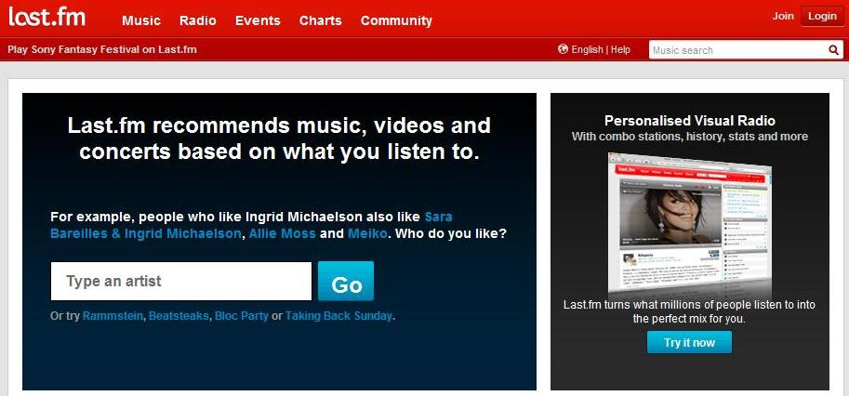

### 2. (Playback control) Misleading Advertisement



### 3. (Registering) feedback, error prevention

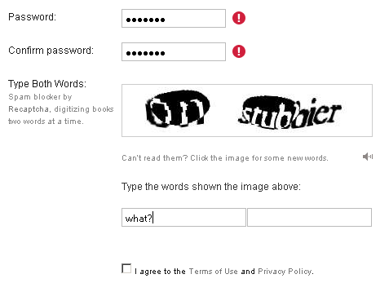

### 4. (Library Control) "Save" Button Colour Scheme



### 

### 5. (Library Control) "Hidden" delete button

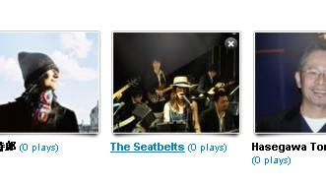

### 6.  (Help & Documentation) Support email hidden

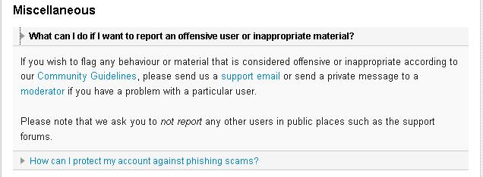

### 

### 7. (Library Control.) Add content models

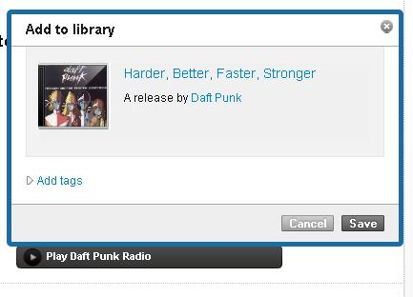

### 8. (Library Control) Success models

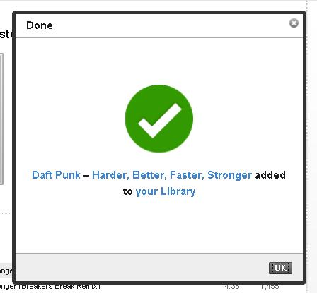

### 9. (Social Networking) Sending message

